**Chapter 3**

**RESEARCH METHODOLOGY**

**Environment**

The research study was conducted at the Philippine Red Cross Misamis Occidental Offices which includes Oroquieta, Ozamiz, and Tangub City Chapters. Red Cross Oroquieta Chapter is located at Capitol Compund Oroquieta City. Then Red Cross Ozamiz Chapter is located at S.M Lao Hospital Compound at Barangay Manabay Ozamiz City and Red Cross Tangub Chapter is located at PRC City Hall Drive Tangub City. Their transactions are National Blood Services, Disaster Management Services, Safety Services, Health Services and Social Services.

**Research Respondent**

The respondents of the study are the personnel who conducted blood donation drives of Red Cross Oroquieta, Ozamiz and Tangub Chapter, and the assigned administrator of the Blood Banking Program of the Philippine Red Cross of the three chapters involve. Each of the blood bank has 1 or 2 administrators so there will be 6 admin that will be interviewed because they will be the one who will handle the system. Then, there will be 70 respondents classified as users and donors to be surveyed and ask about their response on the questionnaires provided because they will also use the website.

**Research Instrument**

The proponents conducted an interview from the respondents of this study as stated above. Open ended questionnaire is being used by the proponents to every respondent in the proposed research. By the help of this questionnaires, the researchers are able to absorb and understand the research more and formulate some applicable ideas which are important to the project and collect such important data and information’s that will guide the proponents accordingly on how this project should be. Questionnaires is consisting of 10 Yes or No questions regarding on the experience of users with their struggles in looking for blood and also their insight on the tendency to have a new and improve system in searching for blood. Interview is consisting of 6 open ended questions and a sort of supporting questions that focus about what are the problems, process, things, reliability, that will be consider and their insight on the possibility of having a new system. Questionnaires and Interview schedule and guide can be seen in appendices.

**Data Gathering Procedure**

The proponents secure a transmittal letter as well as the Memorandum of Agreement to be signed by both parties and it is given to each of the respondent. The proponents visited each office involve in this research to conduct the interview to each of the respondents. The proponents asked the permission of the office administrators of the three offices if they are willing to participate and to be involve in this project before the proponents proceed in conducting an interview that consist of four to six major questions and supporting questions. Interview is conducted in a per to per and oral manner using English as well as local language. The interviewee will then record the answers of the respondents accurately. Questionnaires is conducted in a one respondent in every one questionnaire printed and distributed in a one piece of paper. The questionnaire is answerable by yes or no and it will require to check the corresponding answer by the proponent.

**Treatment of Data**

The information that has been gathered and collected by the proponents are filtered and validated as well as analyze every single information that are recorded by the proponents to be use as guide in developing the system. Interview results are treated as the basis on how the system will be and the survey results are tabulated and documented.

For the presentation of the tabulated results, the following treatment was used for the data gathered. For questions that are answerable by yes or no, percentage and frequency were computed as shown below:

1. Frequency Count – the answer per questions in the questionnaire were quantify, counted and it is considered as frequency.
2. 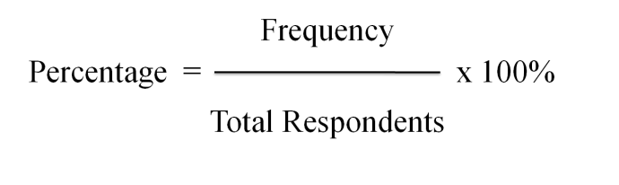Percentage

After getting the percentage, the results will be analyzed and documented to prove the willingness of people to have the system and it will be the basis on formulation to recommend this kind of project.